Section 1: Case Summary

Scenario Title: | Gunshot wound with vascular injury
Keywords: | Gunshot wound, GSW, peripheral vascular injury
Brief Description of Case: | Adult male with penetrating chest and extremity trauma (GSW) with vascular compromise, requiring a thorough and systematic approach.  For senior learners, there will be an additional element of instability from the penetrating chest injury requiring chest tube.

Goals and Objectives
Educational Goal: | Systematic ATLS approach to trauma  Approach to penetrating peripheral extremity trauma  Approach to penetrating chest trauma  Optional considerations for difficulty if senior learner:  - Community hospital with transport considerations  - Adding additional injuries  - Sim actor -> resident who does not know ATLS or inexperienced RN
Objectives:  (Medical and CRM) | Medical objectives:  - Demonstrate a systematic ATLS approach in a case of penetrating trauma.  - Assess and manage penetrating chest trauma according to major trauma guideline algorithms (e.g., ATLS, EAST or WEST)  - Assess and manage penetrating extremity trauma and peripheral vascular injury according to major trauma guideline algorithms (e.g., ATLS, EAST or WEST)  CRM objectives:  - Task prioritizing – systematic approach to trauma with prioritizing of life-threatening findings  - Situational awareness – maintain situational awareness while completing a systematic approach to trauma  - Communication – use concise and effective critical language  - Followership – use a clear and loud voice during ATLS assessment
EPAs Assessed: | F1: Initiating and assisting in resuscitation of critically ill patients  C2. Resuscitating and coordinating care for critically injured trauma patients  C5: Identifying and managing patients with emergent medical or surgical conditions  C13: Performing advanced procedures

Learners, Setting and Personnel
Target Learners: | ☒ Junior Learners |  | ☒ Senior Learners |  |  | ☐ Staff
 | ☒ Physicians | ☐ Nurses |  | ☐ RTs | ☐ Inter-professional
 | ☐ Other Learners:
Location: | ☒ Sim Lab |  | ☐ In Situ |  |  | ☐ Other:
Recommended Number of Facilitators: | Instructors: 1
 | Sim Actors: 1
 | Sim Techs: 1

Scenario Development
Date of Development: | 2021-01-16
Scenario Developer(s): | Mark McKinney
Affiliations/Institutions(s): | University of Ottawa, The Ottawa Hospital Department of Emergency Medicine
Contact E-mail: | markrmckinney@gmail.com
Last Revision Date: | -
Revised By: | -
Version Number: | 1

Section 2A: Initial Patient Information

- Patient Chart
Patient Name: Alex |  |  |  | Age: 26 | Gender: M | Weight: 210 lbs
Presenting complaint: Gunshot wounds
Temp: 36.8 | HR: 115 | BP: 110/65 |  | RR: 26 | O₂Sat: 95% | FiO₂: 21% (RA)
Cap glucose: 5.0 mmol/L |  |  |  | GCS: 14 (E4 V4 M6)
Triage note:
Multiple gunshot wounds. “Minding my own business” downtown. Dropped off by car at emergency doors, drop and run. Patient intoxicated.
Allergies: Unknown
Past Medical History:  Unknown |  |  | Current Medications:  Unknown

Section 2B: Extra Patient Information

A. Further History
Patient is intoxicated, agitated, loud, and difficult but not violent. He will answer direct questions, but he is very evasive regarding what actually happened, saying he was “minding my own business when someone came out from nowhere and shot me”. The weapon was a handgun at about 1-2m away. He thinks the gun was fired about “5 or 6 times, but I’m not sure, it was all so fast”. He will not answer any questions about who dropped him off at the ED.

Complaining of leg pain. He refuses attempts to examine it unless analgesia is given and he is prompted multiple times.

If directly asked, he drank about “3 or 4 shots” at a bar tonight. He also smoked cannabis. No other drug use.

B. Physical Exam
Cardio: Tachycardia | Neuro: No findings
Resp: Tachypnea, GSW as described below | Head & Neck: No findings
Abdo: No findings | MSK/skin: see below for description of GSWs
Other:
Gunshot wounds x3
- Left leg GSW (anterior mid-thigh) that is actively bleeding
- Left leg GSW (posterior upper-thigh/buttock) that is actively bleeding. Only visible if leg is raised or patient is rolled.
- Left clavicle / upper torso GSW with bleeding controlled. Breath sounds initially present bilaterally.

The distal left leg cool, but has a pulse, intact neurologic function, and he does not have pulsatile bleeding or a rapidly expanding hematoma.

POCUS:
Absent lung sliding on left. No pericardial effusion. No free fluid in abdomen.

Section 3: Technical Requirements/Room Vision

A. Patient
☒ Mannequin - adult
☒ Standardized Patient
– either mannequin or standardized patient, depending on degree of intended stress on team’s situational awareness.
☐ Task Trainer
☒ Hybrid – optional hybrid task trainer for chest tube
B. Special Equipment Required
Handheld doppler ultrasound for pulse check
Ultrasound for POCUS
14-16g needle for needle decompression
Chest tube tray
Tourniquet

C. Required Medications
Crystalloid fluids
Blood
Fentanyl, Cephazolin, TXA

D. Moulage
Moulage for gunshot wounds:
- Left leg wound (front thigh) – bleeding; large volume of blood on sheets/leg, sheet underneath is soaked
- Left lower back/buttock wound (back) – bleeding. Should only be visible if the leg is lifted or patient rolled.
- Left clavicle region (front)

Patient should be wearing clothing that needs to be removed.

E. Monitors at Case Onset
☐ Patient on monitor with vitals displayed
☒ Patient not yet on monitor

F. Patient Reactions and Exam
Patient responses:
Complains of leg pain.
Patient is intoxicated, agitated, and loud.
He will answer direct questions, but he is very evasive. He says he was “minding my own business when someone came out from nowhere and shot me”. He will not answer any questions about who dropped him off at the ED.

Exam:
HR 110, RR 26
Left leg gunshot wound anterior mid-thigh that is actively bleeding
Left leg gunshot wound posterior upper-thigh/buttock that is actively bleeding
Left clavicle / upper torso gunshot wound with bleeding controlled, and breath sounds present bilaterally.
Distal left leg is cool but has a pulse and he can move it.

Section 4: Sim Actors and Standardized Patients

Sim Actors and Standardized Patient Roles and Scripts
Role | Description of role, expected behavior, and key moments to intervene/prompt learners. Include any script required (including conveying patient information if patient is unable)
Nurse | Assists with standard resuscitation equipment, medications, and adds to fidelity in terms of patient’s level of agitation and cooperation.  If using a mannequin (rather than an actor), the controller should be very vocal to maintain fidelity. The sim actor should help establish the difficulty managing the patient (e.g., “Sir, please lay back so we can take care of you! You have to let us assess you or we can’t help!”)  May need to provide cues regarding physical exam findings:  - Gunshot wounds x3  - Left leg GSW (anterior mid-thigh) that is actively bleeding  - Left leg GSW (posterior upper-thigh/buttock) that is actively bleeding  - Left clavicle / upper torso GSW with bleeding controlled  - Left leg is cool, but has a pulse and intact neurologic function. He does not have pulsatile bleeding or a rapidly expanding hematoma.  - ABI for left leg is 0.7.  - If team does not ask for ABI after initial management, RN should prompt “I’ve seen TTLs ask for ABIs for this, should we do one?”
Patient  (if using mannequin) | If using a mannequin (rather than an actor), the controller should be very vocal to maintain fidelity.
Patient  (if using SP) | Patient is intoxicated, agitated, loud, and difficult but not violent. He will answer direct questions. Complaining of leg pain, and extreme pain if it is touched. Refusing attempts to examine it, but eventually will allow it if given pain medications and talked to about it multiple times. The left leg should be the patient’s primary concern and he will redirect attention to it constantly.  In stage 2 – the patient becomes short of breath due to a developing tension pneumothorax.

Scenario States, Modifiers and Triggers
Patient State/Vitals | Patient Status | Learner Actions, Modifiers & Triggers to Move to Next State |  | Facilitator Notes
1. Baseline State  Rhythm: Sinus tach  HR: 110  BP: 110/65  RR: 26  O₂SAT: 96%  T: 36.8ºC  GCS: 14 | Intoxicated  Left leg pain  Actively bleeding from left leg | Expected Learner Actions  Gather history from patient  ATLS assessment (i.e. ABCDE)  Monitors, vitals, IV access  Trauma code  Calling for blood  Bloodwork - trauma panel  Cefazolin  TXA  Analgesia (e.g., fentanyl)  POCUS eFAST (absent left lung sliding)  Call for Xray (CXR, pelvis, leg)  Order CT chest and CT-A of left leg | Modifiers  - Screams in pain and refuses assessment if team touches left leg  - BP slowly declines 10mmHg every 2 min until pressure applied to BOTH front and back of left leg  Triggers  - once analgesia given, patient will allow assessment of left leg  - full exposure completed and pressure applied to left leg go to stage 2 | Residents should recognize initial vitals as indication to call for blood  He has ongoing bleeding from his leg, which will be controlled with compression or any hemostatic intervention.  Could consider applying paper clip to map bullet trajectory on CXR
2. Unstable  HR: 125  BP: 85/55  RR: 30  O₂SAT: 90% | Unstable vitals  Loses breath sounds on left | Expected Learner Actions  Oxygen applied  Massive transfusion protocol  Left chest tube +/- needle or finger thoracotomy | Modifiers  - If team calls for consults, they are up in the OR  - After blood and decompress chest HR 110, BP 100/55, sat 96%  Triggers  - Ask for CT-A, or if 4min pass go to stage 3 (leg pulseless) | Xrays are given to team
3. Pulseless leg  Rhythm: Sinus tach  HR: 110  BP: 100/55  RR: 26  O₂SAT: 96% | Left leg now more mottled, cold, pulseless and pain worse | Expected Learner Actions  Recheck leg pulse (absent)  Doppler U/S to confirm absence of pulse  Consult Orthopedic / Vascular surgery emergently | Modifiers  - If team uses Doppler, no pulse is found.  Triggers  - Team asks for consults emergently Trauma team and orthopedics arrive to take patient to OR | - RN should prompt that leg is now appearing mottled / pale / cold

Appendix A: Laboratory Results

CBC  WBC: 14  Hgb: 120  Plt: 276  Lytes  Na 135  K 4.5  Cl 109  HCO₃ 23  AG 3  Urea 7  Cr 80  Glucose 5.5  VBG  pH 7.34  pCO₂ 30  pO₂ 80  HCO₃ 20  Lactate 2.0 | Biliary  AST 72  ALT 35  GGT 120  ALP 40  Bili 8  Lipase 20  Tox  EtOH 35  ASA <1  Tylenol <1  Dig level <1  Osmols 290

Appendix B: ECGs, X-rays, Ultrasounds and Pictures

CXR for juniors – Left clavicle fracture + bullet
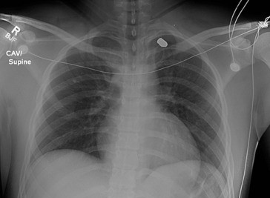
Image from: https://www.sciencedirect.com/science/article/pii/S1930043315305197

CXR for seniors – hemopneumothorax + bullet

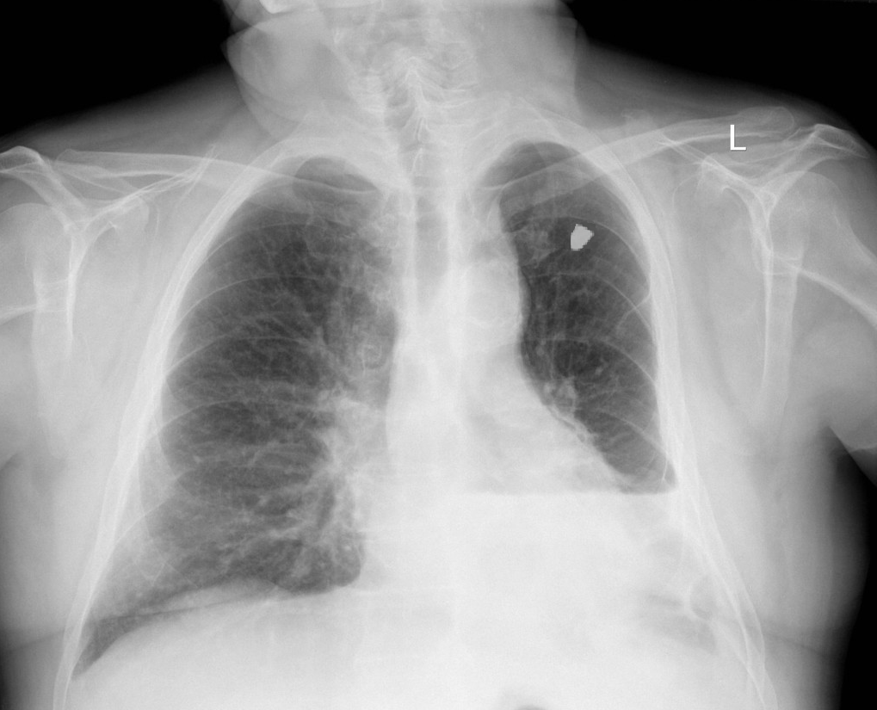
Image from: http://learningradiology.com/archives2007/COW%20265-Hemothorax/hemothoraxcorrect.html

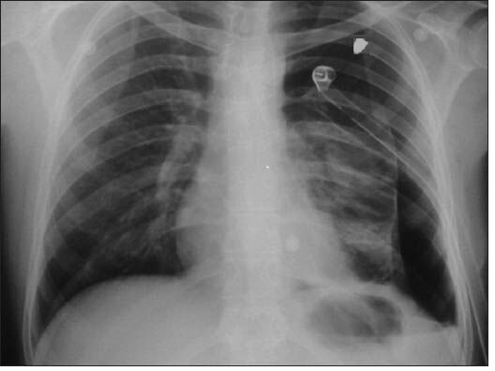
Image from: https://www.researchgate.net/figure/chest-X-ray-shows-persistent-pneumothorax-after-chest-tube-insertion_fig4_260486588

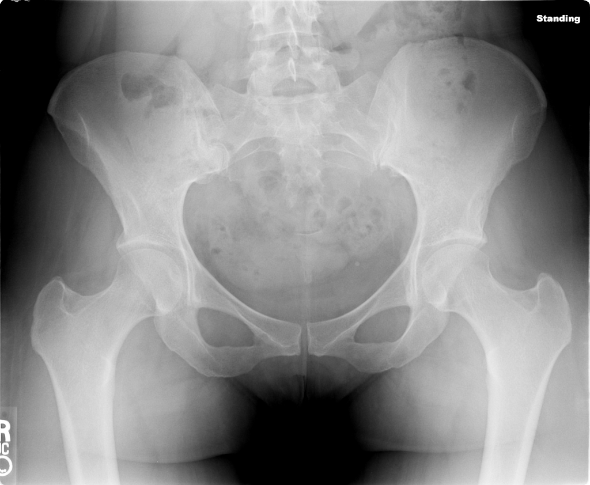
Image from: https://radiopaedia.org/cases/normal-pelvis-x-ray-ap

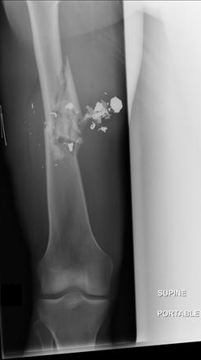
Image from: https://www.orthobullets.com/trauma/1059/gun-shot-wounds

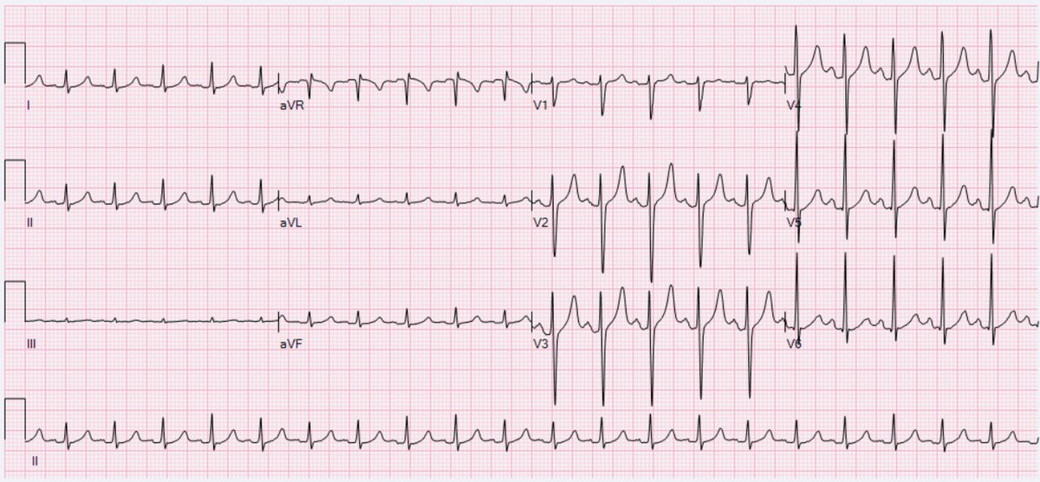
Image from: https://en.wikipedia.org/wiki/Sinus_tachycardia

Appendix C: Facilitator Cheat Sheet & Debriefing Tips

Include key errors to watch for and common challenges with the case. List issues expected to be part of the debriefing discussion. Supplemental information regarding any relevant pathophysiology, guidelines, or management information that may be reviewed during debriefing should be provided for facilitators to have as a reference.

CRM objectives:
- Task prioritizing – discuss a systematic approach to trauma with prioritizing of life-threatening findings (i.e. ATLS approach). Learners may fail to recognize source of bleeding on posterior leg if they do not fully examine the leg or log roll early enough (importance of good exposure).
- Situational awareness – this may be challenged by multiple concurrent findings and the patient’s behaviour.
- Communication and Followership – use a clear and loud voice during ATLS assessment, and critical language when important status changes are noted (e.g. leg becoming pulseless)

Medical objectives:
- Be able to assess and management penetrating extremity trauma and peripheral vascular injury according to major trauma guideline algorithms (e.g., ATLS, EAST or WEST)
- Be able to assess and manage penetrating chest trauma according to major trauma guideline algorithms (e.g., ATLS, EAST or WEST)

Key Points from EAST (2012) document on Penetrating Lower Extremity Arterial Trauma:
Level 1 recommendations:
- CTA may be used as the primary diagnostic study for evaluation of penetrating lower extremity vascular injury when imaging is required.
Level 2 recommendations:
- With hard signs --> should be surgically explored. There is no need for arteriogram in this setting unless the patient has an associated skeletal or shotgun injury. Restoration of perfusion to an extremity with an arterial injury should be performed in less than 6 hours to maximize limb salvage (2002).
- Without hard signs --> those who have abnormal physical examination findings and/or an ABI < 0.9 should have further evaluation to rule out vascular injury.
- Without hard signs, with normal exam and ABI >0.9 --> may be discharged
Level 3 recommendations:
- In cases of hemorrhage from penetrating lower extremity trauma in which manual compression is unsuccessful, tourniquets may be used as a temporary adjunct for hemorrhage control until definitive repair.
- The role of non-invasive Doppler pressure monitoring or duplex ultrasonography to confirm or exclude arterial injury is not well defined. There may be a role for these studies in patients with soft signs of vascular injury or with proximity injuries (2002).
- Nonoperative observation of asymptomatic nonocclusive arterial injuries is acceptable (2002).
- Arteriography for proximity is indicated only in patients with shotgun injuries (2002).

Key algorithm from WEST (2011) document on Peripheral Vascular Injury
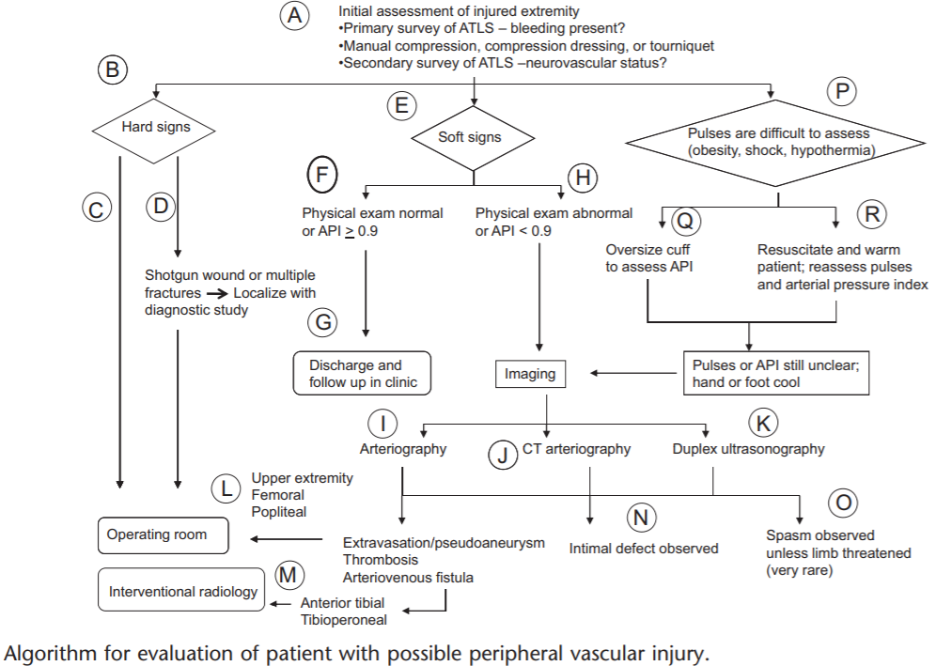

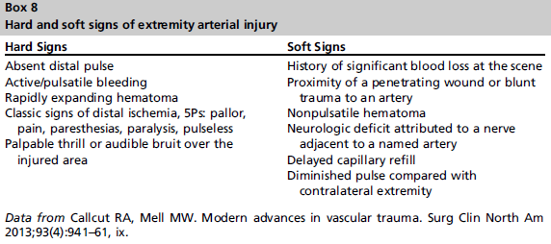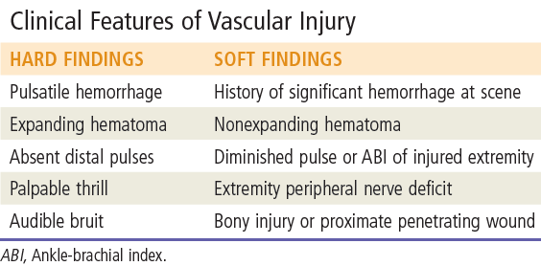

Key algorithm from WEST (n.d., retrieved 2020)

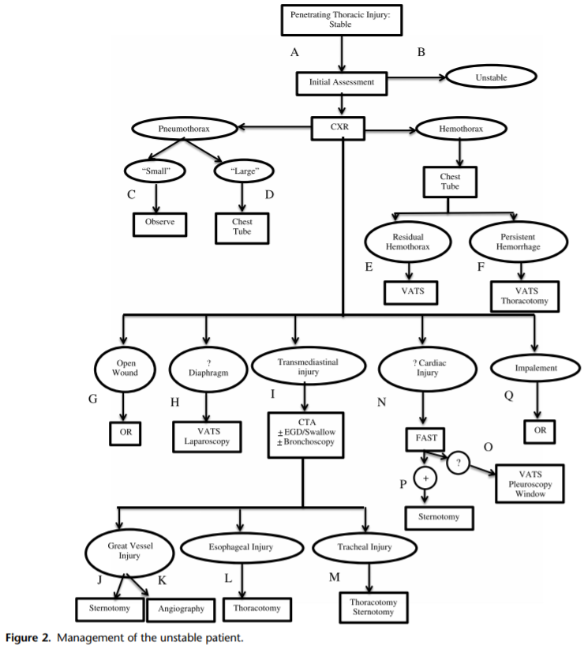

Exam
- inspect widely for any other penetrating wounds (e.g. entry/exit, second wounds, fragments), including looking at back, buttocks, and perineum
- palpating the penetrating wound is not helpful and is very painful
- mark wounds with radio-opaque marker (e.g. paper clip, staple), to assist radiographically
- number of holes + number of missiles should yield an even number

"Danger zone" or "cardiac box" has been described as the region between the epigastrium to the sternal notch and laterally within 3 cm of the sternum

References

- Feliciano DV, Moore FA, Moore EE, West MA, Davis JW, Cocanour CS, et al. Evaluation and Management of Peripheral Vascular Injury. Part 1. Western Trauma Association Critical Decisions in Trauma. J Trauma 2011;70(6):1551-6.
- Fox, Nicole MD, MPH; Rajani, Ravi R. MD; Bokhari, Faran MD, MBA; Chiu, William C. MD; Kerwin, Andrew MD; Seamon, Mark J. MD; Skarupa, David MD; Frykberg, Eric MD Evaluation and management of penetrating lower extremity arterial trauma: An Eastern Association for the Surgery of Trauma practice management guideline, Journal of Trauma and Acute Care Surgery: November 2012 - Volume 73 - Issue 5 - p S315-S320 doi: 10.1097/TA.0b013e31827018e4
- Penetrating chest trauma algorithms, WEST. URL: https://www.westerntrauma.org/western-trauma-association-algorithms/penetrating-chest-trauma/

